Student’s name Teacher’s name

________________________________________ _____________________________

2019
10 5.2 Course Semester 2 Examination

General Instructions  - Reading time – 2 minutes  - Working time –90 minutes  - Write using blue or black pen  Black pen is preferred  - Scientific calculators may be used | Total Marks – 60  - Questions arranged in topics. Attempt questions from all topics.

Section | 1 | 2 | 3 | 4 | Total
 | $$\frac{}{24}$$ | $$\frac{}{12}$$ | $$\frac{}{36}$$ | $$\frac{}{23}$$

Student Comment:

Teacher Comment:
PRACTICE PAPER
Linear and Non Linear Relationships
24 marks
Attempt all Questions
Questions 1 to 4 Multiple choice
Allow about 15 - 20 minutes for this section

Circle the correct answer for Questions 1 to 5

 | Questions 1-2 refer to the diagram below
1. | The gradient of interval AB is:
 | (A) $\frac{9}{6}$ |  | (B) 2 |  | (C) $\frac{2}{3}$ |  | (D) -3
D4

2. | The mid-point of interval AB is:
 | (A) (0 , 2) |  | (B) (-1.5 , 1) |  | (C) (4.5, 3) |  | (D) (-3 , 0)
D4

3. | Line EF has a gradient of $-\frac{3}{2}$. Line CD is perpendicular to line EF. The gradient of line CD is:
 | (A) $-\frac{3}{2}$ |  |  | (B) $-\frac{2}{3}$ |  | (C) $\frac{2}{3}$ |  | (D) $\frac{3}{2}$
C5
4. | Which one of the following lines does the point (2, -2) lie on?
C6 | (A) $y=-3x+4$ |  |  |  | (B) $y=4x+9$
 | (C) $y=3x+2$ |  |  |  | (D) $y=-2x$
Questions 5-8 Short Answer. Show all working. Marks are as shown

5.  C5 |  | Parts a, b, and c refer to the graph shown below. |  |  |  |  |  |  |  | Marks
C5 | a. | Determine the gradient of the line |  |  |  |  |  |  |  | 1
C5 | b. | Find the y-intercept of the line |  |  |  |  |  |  |  | 1
C5 | c. | Write the equation of the line in the form y = mx + b |  |  |  |  |  |  |  | 2
6. |  |  |  |  |  |  |  |  |  | Marks
C5 | a. | A line has the equation $y = 4x – 6$. What is the gradient of a line parallel to this line? |  |  |  |  |  |  |  | 1
C6 | b. | Write the equation of the line that has the same y-intercept as the line $y= 2x + 3$ , and is parallel to the line $y=- \frac{x}{4}-4$ |  |  |  |  |  |  |  | 2
C6 | c. | What is the equation of a line perpendicular to the line $y= 2x + 3$that goes through the point (2, 5) |  |  |  |  |  |  |  | 3
7. | Sketch the graphs given in parts a to c in the axes below |  |  |  |  |  |  |  | Marks
D4 | a. | $$x=-4$$ |  |  |  |  |  |  | 1
D4 | b. | $$y= 4-x$$ |  |  |  |  |  |  | 2
D4 | c. | $$y= 3x-4$$ |  |  |  |  |  |  | 2
8. |  | Use the length unit conversion graph to answer questions.
C5 | a. | Convert 70 AUD to NZD and use these values to find the gradient of the line, to 2 decimal places. |  |  |  |  |  |  | 2
B7 | b. | Use your previous answer to find the constant of proportionality k and write the direct proportion equation between NZD (y) and AUD (x). |  |  |  |  |  |  | 1
C6 | c. | Use the equation to convert 86 NZD to AUD. |  |  |  |  |  |  | 2

Questions 10 to 14 Multiple choice
Right- Angled Triangles
12 marks
Attempt all Questions
Questions 9 to 12 Multiple choice
Allow about 15-20 minutes for this section

Circle the correct answer for Questions 10 to 13

9.  E2 |  | 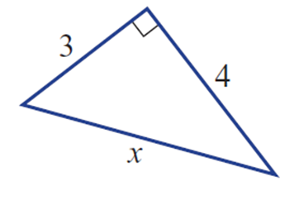  The correct working out to calculate the side x in the triangle shown below is:
 |  | - $x=\sqrt{\left(4^{2}- 3^{2}\right)}$ |  |  |  |  | - $x=\sqrt{\left(4^{2}+ 3^{2}\right)}$
 |  | - x = 4 - 3 |  |  |  |  | - $x=4+3$
10.  D3 |  | In the triangle below the ratio tanθ is given by:
 |  | (A) $\frac{8}{10}$ |  |  | (B) $\frac{8}{6}$ |  | (C) $\frac{6}{10}$ |  | (D) $\frac{8}{10}$
11.  D4 |  | A measurement of an angle is found to be 82°40′15″. What is this measurement rounded to the nearest degree?
 |  | (A) 82º |  |  | (B) 83º |  | (C) 43º |  | (D) 44º
12.  D4 |  | What is the length of the side marked x?  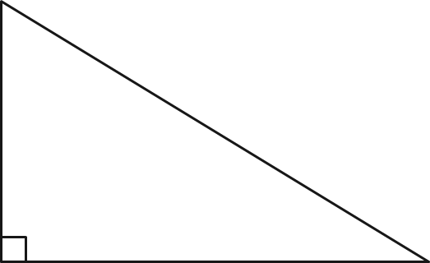  20cm  x  21cm
 |  | (A) 41cm |  |  | (B) 6.4m |  | (C) 29cm |  | (D) 6.4cm
Questions 13-14 Short Answer. Show all working. Marks are as shown

13. |  |  |  | Find the side length x in these right-angled triangles. |  |  |  |  |  |  | Marks
D4 |  | a. |  |  |  |  |  |  |  |  | 2
D4 |  | b. |  | 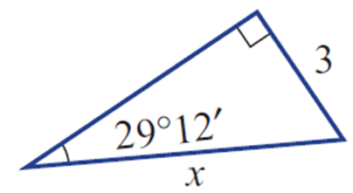  x  7 |  |  |  |  |  |  | 2
14 |  |  |  | Find the missing angle θ in these right-angled triangles, to the nearest minute |  |  |  |  |  |  | Marks
D4 |  | a. |  |   $$41°$$  x  22cm |  |  |  |  |  |  | 2
D4 |  | b. |  |   $$23°15'$$  x  26m |  |  |  |  |  |  | 2
Probability
36 marks
Attempt all Questions
Questions 15 to 18 Multiple choice
Allow about 15- 20 minutes for this section

Circle the correct answer for Questions 15 to 18

15.  D3 | In the following Venn Diagram P(A and B) is:  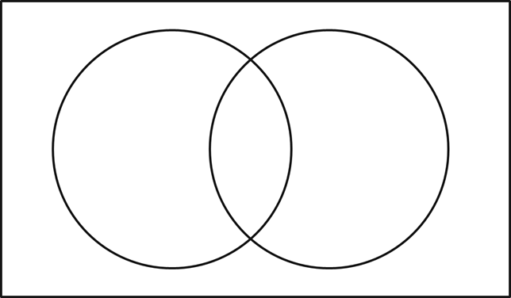  B  A  3  8  12  20
 | (A) 3/43 |  |  |  |  | (B) 8/43 |  | (C) 32/43 |  | (D) 40/43
16.  D3 | In the following two-way table, find the number of elements in ‘not A’.
 | (A) $6$ |  |  |  |  | (B) $12$ |  | (C) $18$ |  | (D) $38$
17.  D4 | Number of heads 0 1 2 3  Frequency 6 26 19 9  An experiment involves tossing three coins and counting the number of heads.  What is the experimental probability of at least 2 heads?
 | (A) 19 |  |  |  |  | (B) 28 |  | (C) 19/60 |  | (D) 28/60
18.  B7 | In the following Venn Diagram P(A | B) (the probability of event A occurring given that event B has occurred) is:    B  A  3  8  12  20
 | (A) 8/43 |  |  |  |  | (B) 20/43 |  | (C) 8/20 |  | (D) 8/28
Questions 19-23 Short Answer. Show all working. Marks are as shown

19. |  |  | A bag contains 6 silver coins and 4 gold coins. Three coins are chosen without replacement.  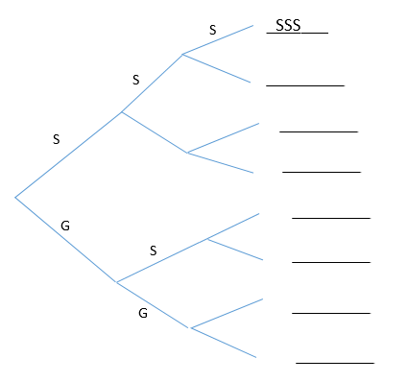  $$\frac{5}{9}$$  ___________  $$\frac{6}{10}$$  ___________  ___________  ___________ |  |  |  |  |  |  |  |  |  | Marks
C6 | a. |  | Complete the tree diagram above and list the sample space. |  |  |  |  |  |  |  |  |  | 4
C6 | b. |  | What’s the probability of obtaining at least 1 silver coin? |  |  |  |  |  |  |  |  |  | 3
C6 | c. |  | What’s the probability of obtaining exactly 1 gold coin? |  |  |  |  |  |  |  |  |  | 2
20. |  |  |   The Venn diagram shows the distribution of elements in two sets, A and B.  B  A  2  7  13  16 |  |  |  |  |  |  |  |  |  | Marks
D4 | a. |  | Transfer the information in the Venn diagram to a two-way table |  |  |  |  |  |  |  |  |  | 9
D3 | b. |  | Find the number of elements in A or B. |  |  |  |  |  |  |  |  |  | 2
D4 | c. |  | Find P(not A). |  |  |  |  |  |  |  |  |  | 2
21. |  |  | A bakery sells 3 flavour doughnuts: plain (P), strawberry (S), and chocolate (C). Steph is in a hurry and randomly selects 2 doughnuts. |  |  |  |  |  |  |  |  | Marks
C6 | a |  | Complete this table showing the possible combinations of doughnuts selected  P S C  P S C (P,P) (S,P) (C,P) |  |  |  |  |  |  |  |  | 2
C6 | b |  | Find the probability that Steph selects a strawberry doughnut. |  |  |  |  |  |  |  |  | 2
22 | Given that a number greater than 3 has been rolled on a fair six-sided die:
B7 | a List the sample space. |  |  |  |  |  |  |  |  |  |  | 1
B7 | b Calculate the probability that this number was 6. |  |  |  |  |  |  |  |  |  |  | 2
B7 | c Calculate the probability that this number was 2. |  |  |  |  |  |  |  |  |  |  | 1
23 | “If you toss a coin and obtain a head three times in a row, there is a greater chance the fourth toss will result in a tail.”  Is this statement correct or incorrect? Explain your answer. |  |  |  |  |  |  |  |  |  |  | 2
B7

Statistics
23 marks
Attempt all Questions
Questions 24 to 27 Multiple choice
Allow about 15- 20 minutes for this section

Circle the correct answer for Questions 24 to 27

24.  E2 | What type of data would the following question generate?  “How would you rate the final episode of Game of Thrones? Excellent, Neutral, Awful.”
 | - Categorical –  Nominal |  |  |  |  | (B) Awful |  | (C) Numerical – Discrete |  | (D) Categorical –  Ordinal
25.  D3 | The results of a mathematics exam are given below. Calculate the mean.  34 82 56 72 91 96 65 76 72 61 58 72 81 42 62
 | (A) $62$ |  |  |  |  | (B) $68$ |  | (C) $72$ |  | (D) $76$
26.  D3 | What is the median of the following set of data?  19 10 12 8 6 3 14 13
 | (A) $10$ |  |  |  |  | (B) $11$ |  | (C) $12$ |  | (D) $7$
27.  C5 | What is the outlier, as represented in this box plot?
 | (A) $5$ |  |  |  |  | (B) $8$ |  | (C) $12$ |  | (D)$15$
Questions 28-30 Short Answer. Show all working. Marks are as shown

28. |  |  | The amount of points scored each game by 2 AFL teams are recorded below:  GWS 107 65 59 83 56 106 67 101 98 88 72 77  Swans 109 95 56 81 76 51 62 66 82 72 69 66 |  |  |  |  |  |  |  |  |  | Marks
D3 | a. |  | Calculate the mean, median and range for each team. |  |  |  |  |  |  |  |  |  | 6
D4 | b. |  | Which team achieved the better scores overall and justify your answer.  Use your results from part (a). |  |  |  |  |  |  |  |  |  | 2
D4 | c. |  | Represent this data in a back-to-back stem-and-leaf plot. |  |  |  |  |  |  |  |  |  | 3
29.  C6 |  |  | Describe the correlation between the depth and length of 11 pools in the area. |  |  |  |  |  |  |  |  |  | Marks  2
30. |  |  | This time-series plot shows the trend of Australian house prices over a 10 year period. |  |  |  |  |  |  |  |  | Marks
C6 | a |  | Describe the general trend in house prices over this time period. |  |  |  |  |  |  |  |  | 2
C6 | b |  | When was the average house price at its lowest during this time period? |  |  |  |  |  |  |  |  | 2
C6 | c |  | What was the average house price in 2016? |  |  |  |  |  |  |  |  | 2

END OF EXAM

Blank Page

